SCATS CMAQ Application

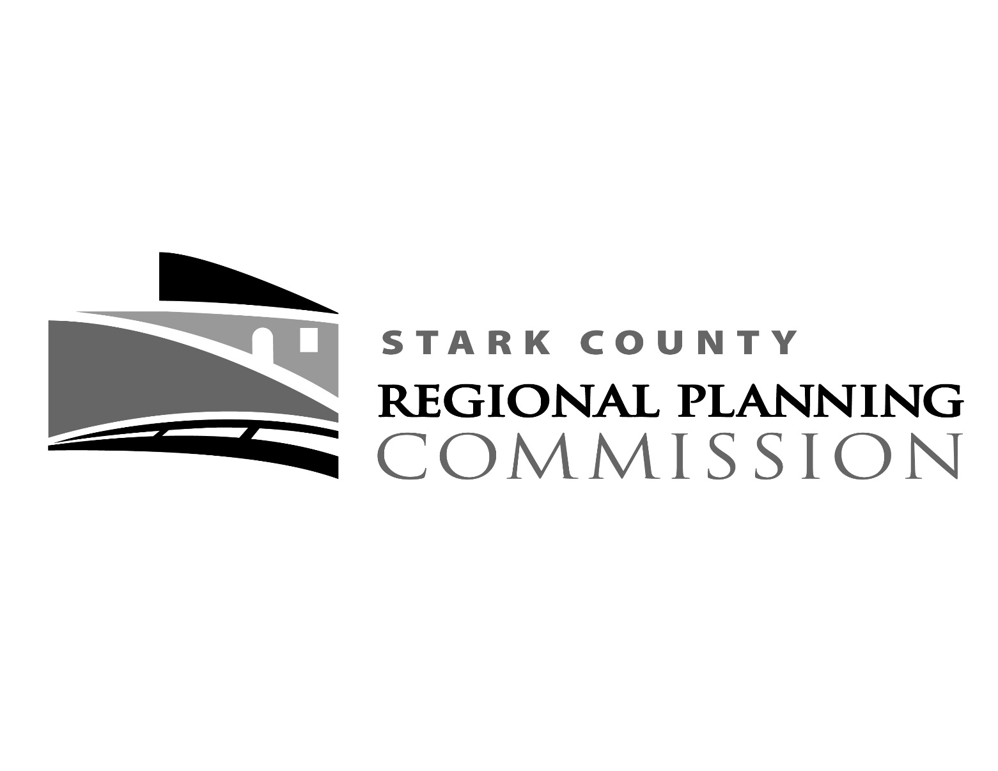

Application Forms and Instructions

This Application Form is to be filled out by the applicant. Supplemental information attached to the form should be as condensed as possible. For example, if a feasibility report has been prepared for the proposal, the applicant should excerpt and summarize rather than simply attaching the entire report.

Tips on the Application Process

Scrutinize the cost vs. benefit when applying for federal funds. The program requirements can be demanding, and what is originally thought of as a small, inexpensive project can spiral quickly into a complicated and expensive project. For example: a project once thought to have a total cost of $85,000 with no right-of-way acquisition became a $120,000 construction cost with an additional $220,000 required for right-of-way acquisition.

Federally funded projects are subjected to many requirements, including the National Environmental Policy Act, the Uniform Relocation Assistance and Acquisition Policies Act, and other ODOT regulations and standards. Most locally planned and funded projects are not subject to these requirements and may often be developed more quickly and at less expense than those that are federally funded. When developing a project schedule, keep in mind that the project will be subject to all of the ODOT Project Development Processes.

Before hiring a consultant, review the experience of the firm with federally funded projects. How many have they successfully advanced through the system? When, where, and what type of project(s)?

The Project Evaluation Criteria is the method under which the OSUCC reviews and ranks the individual applications. An Overall Project Cover Sheet, Milestones Activities, and a detailed explanation of the Scoring Criteria for the Ohio CMAQ Program are shown on the following pages, including Criteria, Measures and Scoring Description, and Frequently Asked Questions and Answers. Examples of Project Type Descriptions are listed within the OSUCC Program, Policies, and Procedures.

The application should also include the following:

- Complete and detailed description of the proposed project and its relation to the intermodal transportation system and any other phases of the project. Location maps, elevations, photographs included, as necessary, to fully illustrate the project.

- Complete and detailed breakdown of the proposed construction/implementation costs inflated to year of expenditure - certified by a professional engineer – including funding sources.

- Complete and detailed description of the project’s characteristics and benefits and how it is included or justified in a local plan or program. Description of how the project will be coordinated with a neighboring jurisdiction if project ends at or crosses a corporation line.

- The anticipated month and year, when the project will be ready for construction. Include the present status of property ownership and plan preparation.

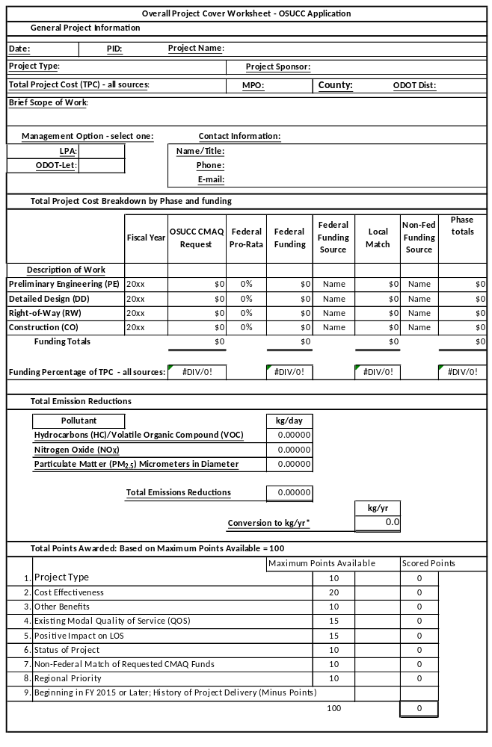

MILESTONE ACTIVITY | EXPECTED DATE  (month/year)
- Project Programmed with ODOT.
- Begin Planning Phase: The date that the planning scope of work is developed.
- Project Initiation Package: The date that the Project Initiation Package is approved by the District.
- Consultant Authorized to Begin Design.
- Purpose and Need Submittal: The date that the Draft Purpose and Need is submitted.
- Begin Environmental Clearance: The date when the scoping for an environmental consultant or scoping for an environmental study is initiated.
- Feasibility Study Submittal: The date when the Feasibility Study is received for review by the District from a consultant or local public agency.
- Preferred Alternative Approval: The date when a single Preferred Alternative is approved the preferred alternative may be established at scope development. If so, provide the scoping date. Otherwise, enter the appropriate approval date associated with the Feasibility Study or Alternative Evaluation Report.
- Preliminary Right-of-Way Plan Submittal: The date when Preliminary RW plans are received for review by the District from a consultant or local public agency.
- Right-of-Way Authorization: The date when authorization is given to a local public agency to begin acquisition activities.
- Stage 2 Design Plan Submittal
- Environmental Document Approval: The date when the responsible agency (FHWA or ODOT) approves the document or the District confirms the project is exempt from documentation.
- Stage 3 Design Plan Submittal
- Right-of-Way Acquisition Complete: Date on which the local public agency certifies the completion of RW acquisition activities. (Utilities/encroachments not included.)
- Final Plans and Bid Package Submittal to ODOT
- Award Contract: The date the local public agency approves a contract with a successful bidder.
- Begin Construction
- Project Completion
- For programs, purchases, studies, and other projects that do not have a construction phase, please provide a schedule for project development (including environmental approval) and funding. Provide an estimate of the date(s) that federal funds would need to be available. Give a summary of the schedule to be followed before the project is ready for funding and while it is being implemented. See also instructions for Item #48 above. Describe other relevant aspects of the project schedule. For example, is the funding schedule contingent upon other actions? Will the project need funding from other sources to proceed?

PROJECT EVALUATION CRITERA
Criteria | Measure | Points
- Project Type  (Maximum Points =10) | Regional rideshare/vanpool programs  Congestion Reduction, Traffic Flow Improvements & ITS  Transit Vehicle Replacement  Freight/Intermodal including diesel engine retrofits  Public Education and Outreach  Transit Service Upgrades  Pedestrian/Bicycle  Alternative Fuels and Vehicles- Non transit  Employer-based Programs  Travel Demand Management  Modal Subsidies and Vouchers  Transit Facility Upgrades  Other TCM's and Misc | 10  10  8  7  6  5  4  4  4  3  3  2  2
Project Type – CMAQ funds can be used on a variety of project types designed to address congestion mitigation and/or emissions reductions. A project will be awarded up to 10 points based on the type of project. (Refer to the Example of Project Types Descriptions.) Some projects may involve multiple project types. The score will be based on the primary project type.

Narrative for Project Type, supporting documentation, and points.

Total points:

Criteria | Measure | Points
- Cost Effectiveness (CE)  (Maximum Points =20)  * Sliding scale | High emissions reduced per dollar cost; Low dollar cost per kilogram reduced.  Medium  Low | 20  *  *
Cost Effectiveness is a measure of the project’s ability to reduce emissions (HC, NO_{x}, and PM_{2.5}) per dollar invested ($ per kg). The OSUCC will apply standard methodologies to estimate the emissions reduction and award up to 20 points on a sliding scale relative to the applications received. The following formula will be used to estimate the cost effectiveness:
CE $/kg= (CMAQ$ Request/Useful Life)/Annual Emissions Reduction

Calculation and brief narrative for Cost Effectiveness, supporting documentation, and points.

Total points:

Criteria | Measure | Points
- Other Benefits  (Maximum Points =10) | Score up to 2 points for each additional project benefit  Improved safety  Fixed Route Transit  Bicycle/Pedestrian  Improved freight movement  Benefits environmental justice population | 0 - 2  0 - 2  0 - 2  0 - 2  0 - 2
Other Benefits - Many projects have ancillary or additional benefits beyond the primary goals of the CMAQ program. This criterion allows for a range of points based on several categories including safety, fixed route transit service, bike/pedestrian, improved freight movement and benefits to environmental justice populations. Up to 2 points may be awarded for projects that demonstrate high positive impacts from any or all of the categories up to a maximum of 10 points

Narrative for Other Benefits, supporting documentation, and points.

Total points:

Criteria | Measure | Points
- Existing Modal Quality of Service (QOS)  (Maximum Points =15) | Very Low or Level of Service F  Low or E  Medium or D  High or A-C | 15  10  4  0
Existing (QOS) documents the existing congestion in the project area. A project may be awarded up to 15 points depending upon the current QOS. No points will be awarded to projects to improve modes currently operating at LOS C or better. The applicant must provide documentation and data showing how the LOS was determined. For transit projects, the application is to provide information to assess the “level of service” primarily with respect to the lack of capacity for which the project will provide benefits. Similarly, for bike or pedestrian projects, information is to be provided to demonstrate the poor level of service being provided for users of those modes. However, for transit, bike and pedestrian projects, lack of service or absence of a facility does not equate to poor level of service. Information must be provided that demonstrates there is demand for the service or facility that is not being met

What is the current and projected LOS? Please provide supporting documentation.

Total points:

Criteria | Measure | Points
- Positive Impact on LOS  (Maximum Points =15) | High impact  Medium impact  Low impact  No impact | 15  10  3  0
The Positive Project on LOS assesses the impact the proposal will have on the existing situation, ranging from 0 to 15 points. Some examples of Positive Impacts for LOS for Roads, Transit and Bicycle and Pedestrian LOS Impacts are shown below.

ROAD LOS IMPACTS
HIGH | MEDIUM | LOW
The project will improve the LOS will from F to C | The project will improve the LOS from F to D or from E to C | The project will improve the LOS from F, E or D by one level or substantially reduce delay if resulting LOS remains F.

TRANSIT QOS IMPACTS
HIGH | MEDIUM | LOW
Significantly increases service and reliability. Interconnect or fare coordination project, bus turnouts at major intersections, intermodal facility accommodating major transfers, reduces travel time. Fleet expansion will be considered high impact. | Increases service and reliability in a minor capacity, interconnect or fare coordination project, general bus turnouts, intermodal facility accommodating major  transfers. Vehicle replacement will be considered a medium impact. | Increases passenger comfort or convenience, bike racks.

BICYCLE and PEDESTRIAN QOS IMPACTS
HIGH | MEDIUM | LOW
Facility that will primarily serve commuters and/or school sites, sidewalks where none exist. Completes final pieces of a significant regional route. | Mixed use bicycle/pedestrian facility (recreation & commuter), usable sidewalk segments including upgrades and new installations and signage. | Public educational, promotional, and safety programs that promote and facilitate increased use of non-motorized modes of transportation.

FREIGHT QOS IMPACTS
HIGH | MEDIUM | LOW
Facility or equipment that will improve the movement or processing of freight by 50% above existing conditions or other qualitative assessment | Facility or equipment that will improve the movement or processing of freight by 25% above existing conditions or other qualitative assessment | Facility or equipment that will improve the movement or processing of freight by 15% above existing conditions or other qualitative assessment

What is the Positive Impact on LOS? Please provide supporting documentation.

Total points

Criteria | Measure | Points
- Status of Project  (Maximum Points =10) | Construction plans complete  Non construction activity ready for authorization  ROW clear and complete  Environmental document complete  Environmental document underway | 10  8  8  6  2
The Status of Project points reflect the existing status of the project. The closer a project is to the construction/implementation phase, the more points it will receive. Those that are early in the project development process with environmental studies underway will receive 2 points. Projects with completed environmental status earn 6 points; those with right-of-way cleared and complete will be awarded 8 points. Non construction projects that do not require right-of-way and are ready for authorization such as a bus purchase also earn 8 points. Projects with construction plans complete earn 10 points.

Narrative for Status of Project, supporting documentation, and points.

Total points:

Criteria | Measure | Points | Measure | Points
- Non-Federal Match of Requested CMAQ Funds of the phase(s) cost  (Maximum Points =10) | Above 40%  >35 to 40%  >30 to 35%  >25 to 30%  >20 to 25%  Up to 20% | 5  4  3  2  1  0 | Greater than $2.0 M  $1.0 M to $2.0 M  >$500,000 to $1.0 M  $150,000 to $500,000  $50,000 to $150,000  $0 to $50,000 | 5  4  3  2  1  0
The Non-Federal Match of Requested CMAQ Funds – The criteria rewards applicants that increase their local share to “overmatch” the required rate for local participation. The standard match rate for federal CMAQ funds is 20 percent (although there are exceptions); however, the applicant can gain up to a maximum of 10 points through overmatching.

Narrative for Non-Federal Match, supporting documentation, and points.

Total points:

Criteria | Measure | Points
- Regional Priority  (Maximum Points =10)  (determined by each MPO) | First Priority Project  Second Priority Project  Third Priority Project  Fourth Priority Project  All Other | 10  7  4  2  0
Regional Priority – MPO’s will be responsible for collecting, reviewing for completeness and ranking CMAQ applications from the eligible recipients in their regions. Top ranking projects from each region will receive 10 points, second highest receives 7 points, third highest receives 4 points, fourth highest receives 2 points. All others receive 0 points. Each MPO will develop their own approach to determining their regional priority. In cases where a project is in more than one MPO an average point score will be used.

Narrative for Regional Priority, supporting documentation, and points.

Total points:

Criteria | Measure | Points
- Beginning in FY 2015 or Later: History of Project Delivery  By Project Sponsor in the previous two years | One project slipped past programmed year  Two of more project slipped past programmed year  One or more projects cancelled | -5  -10  -10
History of Project Delivery – It is critical that projects that compete for and receive Ohio CMAQ dollars be delivered on time and within budget in order to fully realize the user benefits for Ohio citizens. Therefore, an applicant who has accepted CMAQ dollars in FY 2015 or later and allows the project to slip beyond the programmed year of obligation will be penalized 5 points on all subsequent applications for a period of two years. Applicants that allow two or more projects to slip will be penalized 10 points on subsequent applications for a period of two years. Project cancellation will also be cause for a 10 points reduction for a period of two years. Exceptions may be granted by the OSUCC for circumstances beyond the control of the applicant.

MAXIMUM POINTS 100 Applicant total points for this project. | 0

Frequently Asked Questions and Answers
- What is the purpose of the Ohio Statewide Urban Congestion Mitigation Air Quality Program?
In November 2012, the Director of the Ohio Department of Transportation (ODOT) announced the creation of an Ohio Statewide Urban Congestion Mitigation and Air Quality (CMAQ) Program. The intent of the program is to more quickly advance eligible projects that improve air quality, reduce congestion, and eliminate delay/improve safety, in addition to utilizing statewide CMAQ funding in the year funds are allocated.

- What is the CMAQ Program?
The CMAQ program was established by the Intermodal Surface Transportation Efficiency Act (ISTEA) of 1991, and continues under the current federal transportation bill Moving Ahead for Progress in the 21st Century (MAP-21); with an emphasis area on addressing PM2.5. The CMAQ Program provides a flexible funding source for transportation projects and programs to help meet the requirements of the Clean Air Act. Funding is available to reduce congestion and improve air quality for areas that do not meet (nonattainment areas) the National Ambient Air Quality Standards (NAAQS) for ozone, carbon monoxide, or particulate matter, and for areas that were out of compliance but have now met (maintenance areas) the NAAQS.

Generally, projects eligible under the CMAQ program prior to enactment of MAP-21 remain eligible. All CMAQ projects must demonstrate three primary elements of eligibility: 1.) transportation identity as described within the programmatic parameters in the CMAQ Final Program Guidance Section VII – Project Eligibility Provisions – D. Eligible Projects and Programs; 2.) emissions reduction; and 3.) location in or benefitting a nonattainment or maintenance area.

- What is the Ohio Statewide Urban Congestion Mitigation Air Quality Committee (OSUCC)?
In January 2013, the Ohio Association of Regional Councils (OARC) Executive Directors established OSUCC, charging them with the task of developing protocols for managing the Congestion Mitigation Air Quality (CMAQ) Program. The CMAQ Program provides approximately $60 plus million annually; although this amount may vary for each application round, to Ohio’s eight largest Metropolitan Planning Organizations (MPOs) with populations larger than 200,000.

- What MPOs sit on OSUCC?
The OSUCC consists of representatives from the following agencies:
- Akron Metropolitan Area Transportation Study (AMATS)
- Eastgate Regional Council of Governments (Eastgate)
- Miami Valley Regional Planning Commission (MVRPC)
- Mid-Ohio Regional Planning Commission (MORPC)
- Northeast Ohio Areawide Coordinating Agency (NOACA)
- Ohio-Kentucky-Indiana Regional Council of Governments (OKI)
- Stark County Area Transportation Study (SCATS)
- Toledo Metropolitan Area Council of Governments (TMACOG)

- What types of projects are eligible?
Non-capacity adding projects that can demonstrate an emissions reduction are generally eligible. For a complete listing of eligible projects, please visit the following link to review FHWA’s Final CMAQ Program Guidance: http://www.fhwa.dot.gov/environment/cmaqpgs/cmaq08gd.pdf, specifically Section VII – Project Eligibility Provisions – D. Eligible Projects and Programs.

- What types of project are not eligible?
Projects which add new capacity for single-occupancy vehicles are not eligible. Maintenance projects are not eligible.

- Can any entity submit a project for CMAQ funding consideration?
Applicants are limited to qualified government entities that are members of one of the large MPOs located within the metropolitan planning area. Projects located within the boundaries of a non-member jurisdiction are not eligible for Federal CMAQ funds unless the member jurisdiction applying for funds would be the owner or maintainer of the facility being constructed.

- Does an applicant submit projects directly to OSUCC since there are eight MPOs and when is the solicitation process?
The solicitation process for projects will consist of two parts.
- First, each of the eight large MPO will solicit projects from their area. Each MPO shall conduct this part in whatever manner that best meets their local circumstances.
- Second, each MPO will then provide the OSUCC the application form for each project from their area, including the MPO ranking, and the project scoring table.

Following this solicitation the OSUCC will review the scoring provided by the MPO’s. OSUCC may adjust project scores to ensure the scoring criterion was applied uniformly across all of the projects. This will lead to a listing of projects ranked by score.

- What is the schedule of activities for each CMAQ funding round?
- May of each year: Identify total amount by year of CMAQ funding to be available for new projects.
- May – August: Each MPO solicits projects or otherwise identifies projects to be submitted to the OSUCC.
- September: Projects submitted to OSUCC.
- September – November: OSUCC review of projects and project scoring.
- November: OSUCC identifies the recommended program of projects for funding.
- December: Executive Directors approve projects for funding. All projects will follow the individual MPO public involvement policies in accordance with the standard STIP/TIP public involvement processes.

- Where can an applicant obtain a CMAQ application form?
Each MPO solicit projects from their respective area. Applicants should contact the respective MPO for their area.

Council of Fresno County Governments, January 2006 CMAQ Call for Projects
Council of Fresno County Governments, January 2006 CMAQ Call for Projects

